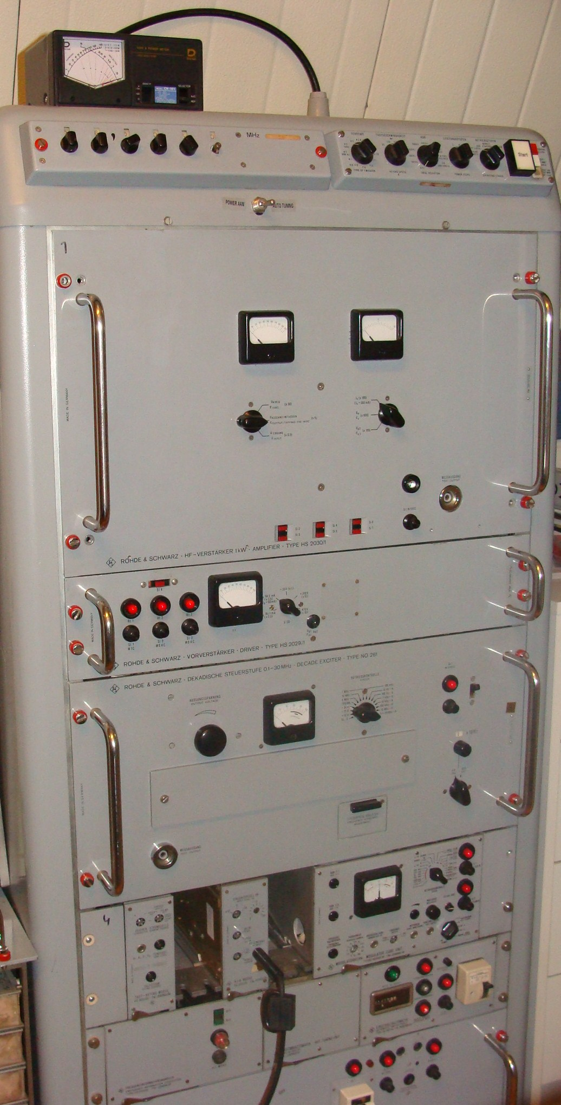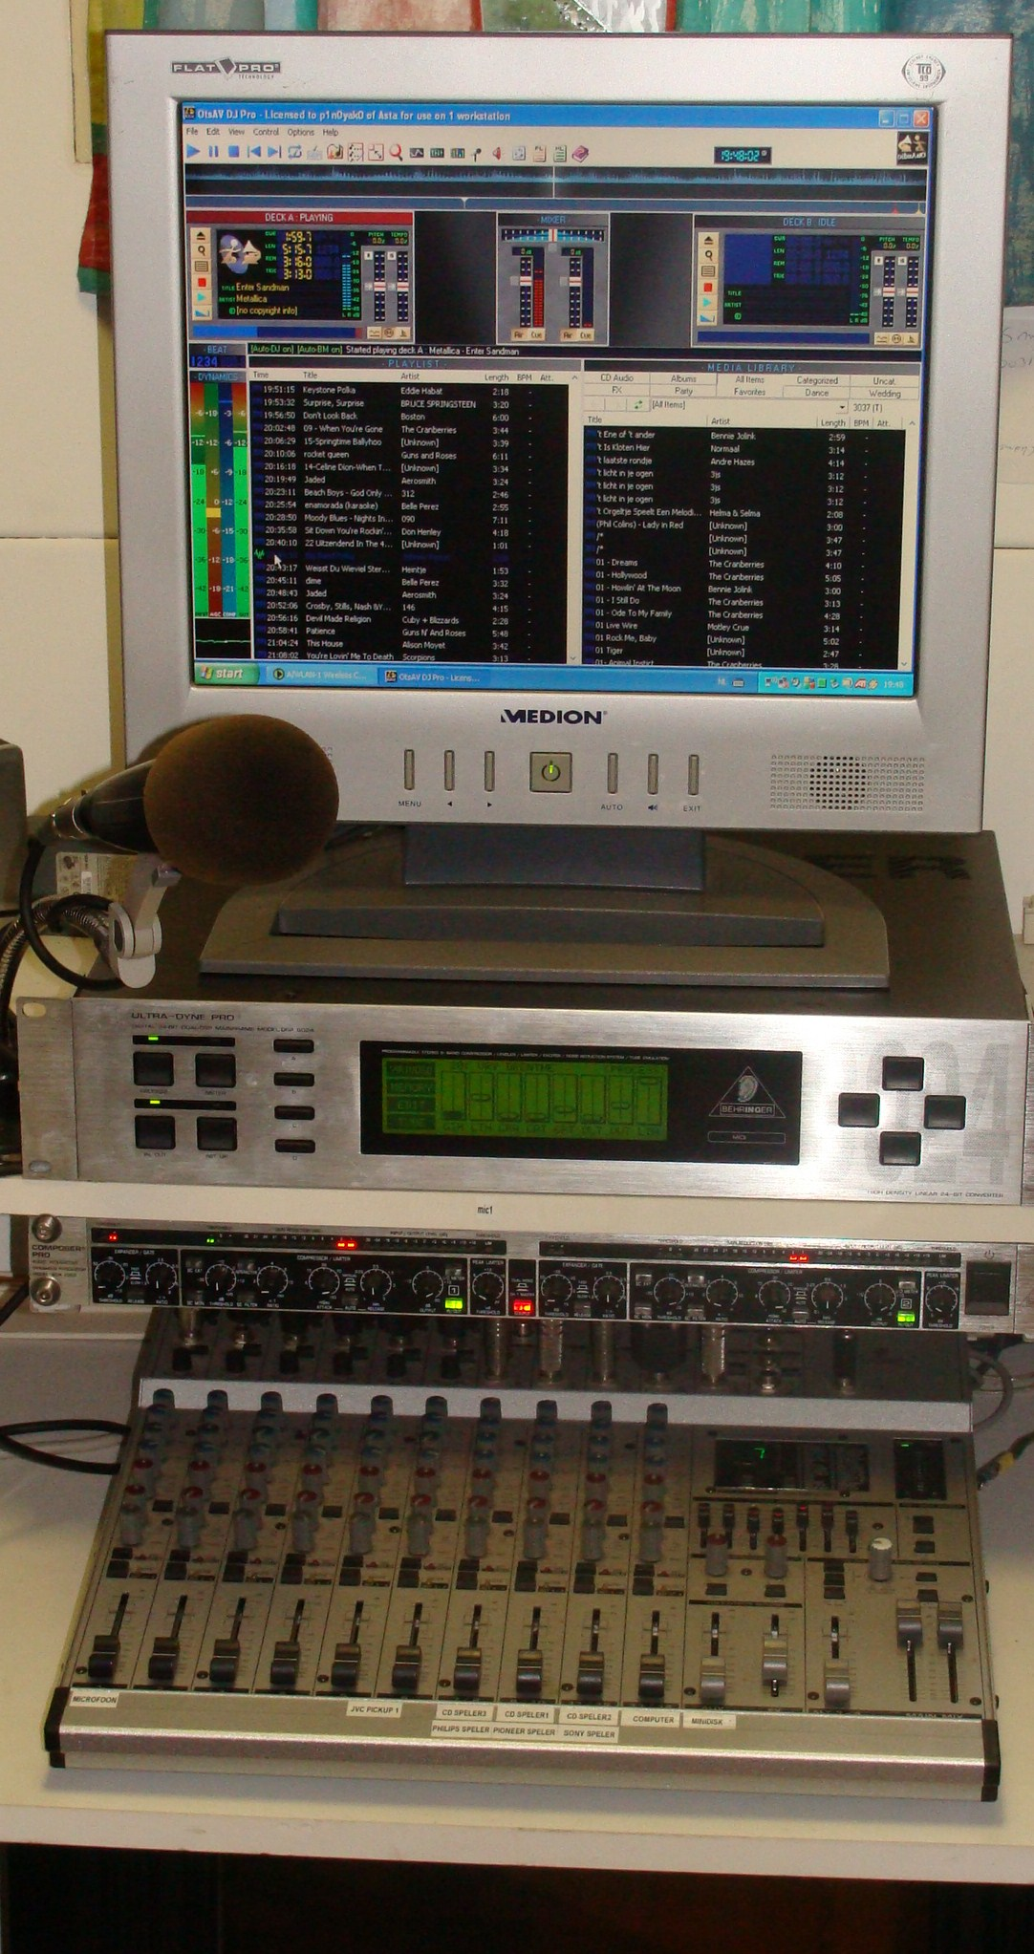

http://www.listen.to/eastcoastholland

Freq; 6205 Khz. 48m.band
Date;06-09-2009
Time;07.00-09.00 utc
Power; 300watts max.
This reception is for; Achim Bruckner in Deutschland.
Greetings from radio E.C.H. dj Ronald.

Greetings from the netherlands E.C.H

