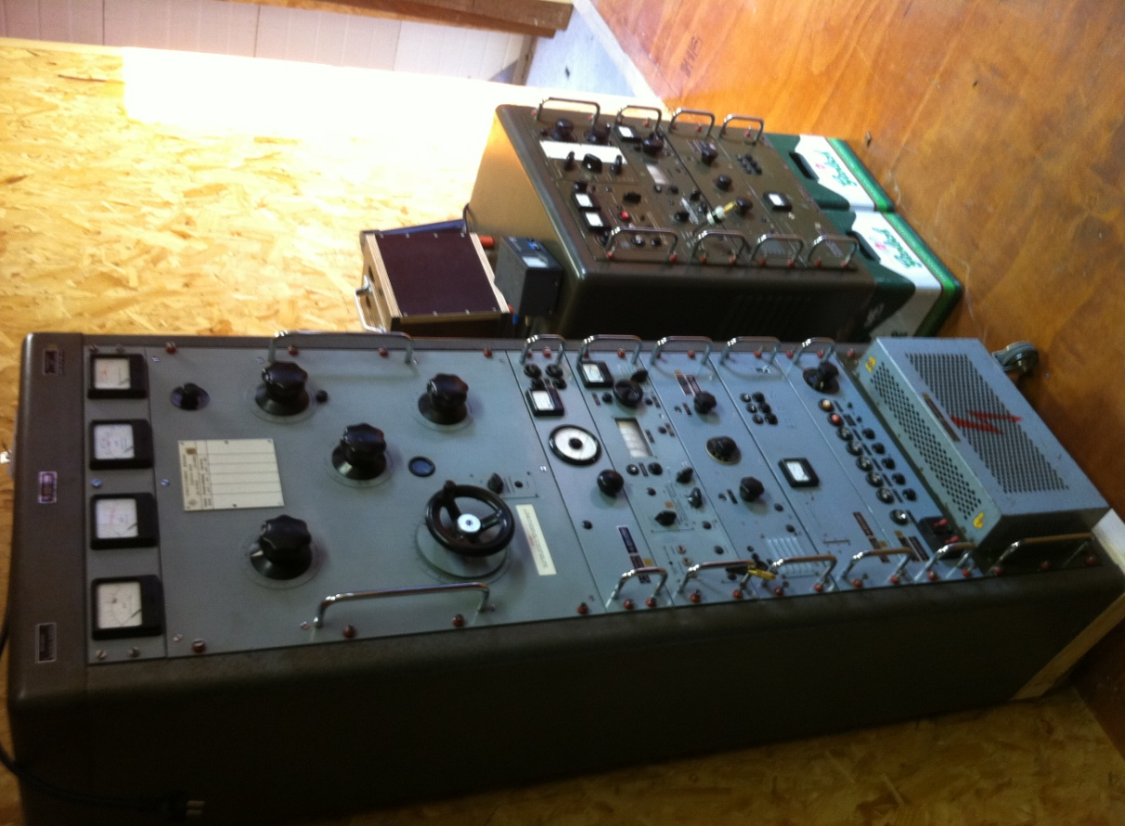
QSL CONFIRMATION TO: ACHIM BRUCKNER
DATE: 16-1-12 TIME: 15:20 UTC FREQ: 6426KHZ TX: SK010 35WATTS
ANTENNA: INVERTED V
REMARKS: THANKS FOR YOUR REPORT !!!

